- Copyright for test papers and marking guides remains with West Australian Test Papers.
- The papers may only be reproduced within the purchasing school according to the advertised conditions of sale.
- Test papers must be withdrawn after use and stored securely in the school until Friday 5th December 2014.



YEAR 11 CHEMISTRY
2A/2B
2014

MARKING GUIDE

Section One: Multiple-choice (50 marks)

1 | □ a □ b ■ c □ d |  | 6 | □ a ■ b □ c □ d |  | 11 | □ a ■ b □ c □ d
2 | ■ a □ b □ c □ d |  | 7 | □ a ■ b □ c □ d |  | 12 | □ a □ b ■ c □ d
3 | □ a ■ b □ c □ d |  | 8 | ■ a □ b □ c □ d |  | 13 | □ a ■ b □ c □ d
4 | □ a □ b ■ c □ d |  | 9 | ■ a □ b □ c □ d |  | 14 | ■ a □ b □ c □ d
5 | □ a □ b □ c ■ d |  | 10 | □ a □ b □ c ■ d |  | 15 | □ a ■ b □ c □ d

16 | ■ a □ b □ c □ d |  | 21 | ■ a □ b □ c □ d
17 | □ a □ b □ c ■ d |  | 22 | □ a ■ b □ c □ d
18 | □ a ■ b □ c □ d |  | 23 | □ a ■ b □ c □ d
19 | ■ a □ b □ c □ d |  | 24 | ■ a □ b □ c □ d |  |  | (2 marks per question)
20 | □ a □ b □ c ■ d |  | 25 | □ a □ b ■ c □ d

Section Two: Short answer (80 marks)

Question 26 (8 marks)

All liquids, and in fact some solids, have a vapour pressure.

(a) For each of the following pairs of solutions, circle the one that would have the higher vapour pressure. (3 marks)

(i) 50 mL water at 25 °C OR 50 mL water at 50 °C

(ii) 0.5 mol L⁻¹ NaCl (aq) OR 0.5 mol L⁻¹ MgCl₂ (aq)

(iii) unsaturated KNO₃ (aq) OR saturated KNO₃ (aq)

(b) Explain the difference between a saturated and unsaturated solution. (2 marks)

- saturated, maximum amount of solute dissolved in solvent (for a given temp)
- unsaturated, less than maximum solute dissolved

(c) For your answer to (a) part (ii), explain why your chosen substance has a higher vapour pressure. (3 marks)

- MgCl₂ dissociates into 3 ions per formula unit, NaCl only dissociates into 2
- Therefore NaCl has fewer solute particles present for the same concentration
- This allows a larger surface area of solvent to be exposed and therefore evaporate, contributing to a higher vapour pressure

Question 27 (9 marks)

Consider the seven (7) species shown below;

S | P | Ca²⁺ | Na | S²⁻ | Mg²⁺ | O
sulfur atom | phosphorus atom | calcium ion | sodium atom | sulfide ion | magnesium ion | oxygen atom

(a) Which of the species above have the same electron configuration? (1 mark)

- Ca²⁺ and S²⁻

(b) Which of the species above have the same number of protons? (1 mark)

- S and S²⁻

(c) Write the electron configuration for P. (1 mark)

- 2,8,5

(d) Write the electron configuration for the Na-22 isotope. (1 mark)

- 2,8,1

(e) If you had an element with the electron configuration 2, 8, 8, 1, which of the species above would be in the same group of the periodic table? (1 mark)

- Na

(f) Explain why sulfur has a tendency to form the S²⁻ ion. (2 marks)

- S has 6 valence electrons, stable electron arrangement means 8 in the valence shell
- Therefore S will react in order to pick up 2 more electrons, giving the S²⁻ ion

(g) In terms of electron arrangement, what do the metallic elements in groups 1, 2 and 13 have in common? Explain how this contributes to their metallic nature. (2 marks)

- all generally have 1-3 electrons in the valence shell
- these valence electrons become the ‘delocalised sea’ characteristic of metallic bonding

Question 28 (8 marks)

A sample of copper(II) iodide powder was dissolved in water. This solution was then split into three (3) test tubes and a separate reaction was performed in each.

(a) Draw the structural formula of copper iodide, representing all valence shell electron pairs either as : or –. (2 marks)

••
••
••
••
2 I
Cu
2+
-

(b) Chlorine gas was bubbled through the first test tube. Write the oxidation and reduction half-equations for the reaction that would have taken place. (2 marks)

oxidation: 2 I⁻ (aq) → I₂ (aq/s) + 2e⁻

reduction: Cl₂ (g) + 2e⁻ → 2 Cl⁻ (aq)

(c) Zinc metal was added to the second test tube. Describe the predicted observations for this reaction. (2 marks)

- a silver metal dissolves in blue solution, blue solution fades to colourless as salmon pink metal forms

(d) Lead(II) nitrate was added to the third test tube. Write the equation for the reaction that would have taken place. Include in your answer only those species that react. (2 marks)

- Pb²⁺ (aq) + 2 I⁻ (aq) → PbI₂ (s)

Question 29 (6 marks)

The reaction between Diet Coke and Mentos became a YouTube sensation a few years ago. This initiated much research into the chemistry behind the reaction.

MythBusters found that mint flavoured Mentos had a much faster and more violent reaction than fruit flavoured Mentos, because the surface of the mint Mentos are much rougher.

(a) Explain why this would have affected the rate of the reaction. (2 marks)

- rougher surface of mentos would increase surface area available for reaction
- results in higher number of collisions, therefore faster reaction rate

Another study found that the reaction was much faster when the Diet Coke was first heated before adding the Mentos.

(b) Explain why this would have affected the rate of the reaction. (2 marks)

- increased average kinetic energy of particles so more can overcome E_{a}
- results in higher number of collisions / higher proportion of successful collisions, therefore faster reaction rate

When a bottle of Diet Coke (or any soda) is opened, you hear a characteristic ‘fizz’, which is the release of carbon dioxide gas. The Diet Coke and Mentos reaction is actually just a much faster version of this physical reaction.

(c) In terms of gas pressure, explain why a bottle of Diet Coke will ‘fizz’ and release carbon dioxide when opened. (2 marks)

- CO₂ gas is dissolved in soft drink under high P
- when bottle cap removed, P inside bottle drops dramatically causing solubility of CO₂ to decrease (seen as bubbles emerging from the drink)
(gas solubility is proportional to P)

Question 30 (9 marks)

Consider the information given in the table below.

 | Melting point (°C) | Conductivity as solid | Conductivity as liquid
W | -114 | x | x
X | 650
Y | 1725 | x | x
Z | 1087 | x

(a) Which substance(s) is/are most likely to contain ionic bonds? (1 mark)

- Z

(b) Explain what a covalent bond is and state which substance(s) is/are most likely to contain covalent bonds. (2 marks)

- covalent bond is when atoms share electrons to achieve stable electron configuration
- W and Y

(c) Explain why substance X can conduct in both the solid and liquid states but substance Y can conduct in neither. (4 marks)

- X is metallic
- Therefore presence of delocalised electrons allows conductivity in both states
- Y is covalent network
- Highly localised bonding, no mobile charge available

(d) Substance Z was added to water and did not conduct electricity. Explain this observation and suggest a possible identity for substance Z. (2 marks)

- insoluble ionic substance
- any insoluble salt

Question 31 (6 marks)

A laboratory technician had a stock solution of 1.85 mol L⁻¹ chromium (III) sulfate, Cr₂(SO₄)₃. She took 17.3 mL of this solution and added it to 358 mL of water.

(a) Calculate the concentration of the dilute Cr₂(SO₄)₃ solution. (2 marks)

c₂ = c₁V₁ / V₂
= 1.85 x 0.0173 / (0.0173 + 0.358)
= 0.032005 / 0.3753
= 0.085278 mol L⁻¹
= 0.0853 mol L⁻¹

She then added 127 mL of 0.350 mol L⁻¹ sodium sulfate (Na₂SO₄) to the dilute Cr₂(SO₄)₃.

(b) Calculate the concentration of sulfate ions in the resulting solution. (4 marks)

n(Cr₂(SO₄)₃) = 0.0325005
n(SO₄²⁻) = 3 x 0.0325005
= 0.096015

n(Na₂SO₄) = cV
= 0.350 x 0.127
= 0.04445
= n(SO₄²⁻)

n(SO₄²⁻ total) = 0.096015 + 0.04445
= 0.140465 mol

C(SO₄²⁻) = n/V
= 0.140465 / 0.5023
= 0.27964 mol L⁻¹
= 0.280 mol L⁻¹

Question 32 (8 marks)

Consider the following six (6) solutions. Assume they each have a 0.5 mol L⁻¹ concentration.

HNO₃ NaOH H₃PO₄ NH₃ Ba(OH)₂ CH₃COOH

(a) Which solution would be the best electrical conductor? (1 mark)

- Ba(OH)₂

(b) Which substance has the lowest pH? (1 mark)

- HNO₃

(c) Which substance would cause universal indicator to turn purple? (1 mark)

- NaOH OR Ba(OH)₂

(d) Write both an Arrhenius and a Bronsted-Lowry equation showing how HNO₃ dissolves in water. (2 marks)

Arrhenius: HNO₃ → H⁺ + NO₃⁻

Bronsted-Lowry: HNO₃ + H₂O → H₃O⁺ + NO₃⁻

(e) Which substance would have a pH closest to 8? (1 mark)

- NH₃

The CH₃COOH solution is added to the NaOH solution.

(f) Write the equation for the reaction that would have taken place. Include in your answer only those species that react. (2 marks)

- CH₃COOH (aq) + OH⁻ (aq) → CH₃COO⁻ (aq) + H₂O (l)

Question 33 (9 marks)

Hydrazine (N₂H₄) is a toxic, unstable substance, which is sometimes used in rocket fuels. When hydrazine is passed over a catalyst such as molybdenum nitride on alumina, it decomposes very quickly according to the following equation;

N₂H₄ (l) → N₂ (g) + 2 H₂ (g)

The activation energy for this reaction is 295 kJ mol⁻¹ and the activation energy for the reverse reaction is 1335 kJ mol⁻¹.

(a) Calculate the enthalpy change (ΔH). (1 mark)

- ΔH = -1040 kJ mol⁻¹

(b) Sketch a labelled potential energy diagram for the uncatalysed decomposition of hydrazine. Label the activation energy, reverse activation energy and enthalpy change. (4 marks)
Progress of reaction
Potential energy (kJ)
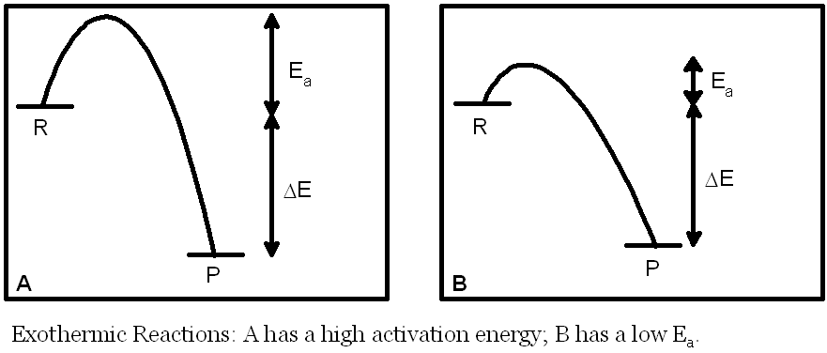
E_{a}(rev) = 1335 kJ

ΔH = -1040 kJ
E_{a} = 295 kJ

(c) If the molybdenum nitride on alumina catalyst had been used, show the effect this would have on the potential energy diagram above. (1 mark)

- (see dotted line)

(d) What effect (higher, lower, unchanged) would the addition of a catalyst have on the value of each of the following? (3 marks)

(i) Activation energy lower

(ii) Reverse activation energy lower

(iii) Enthalpy change unchanged

Question 34 (7 marks)

(a) Complete the following table by either naming the molecule using the IUPAC system or drawing a structural diagram of the molecule. (3 marks)

 | IUPAC Name | Structural Diagram
A | 4,4-difluoro-trans-pent-2-ene | C = C  H CF₂ – CH₃  H₃C H
B | 1,1,3-tribromocyclohexane | Br  Br
C | 4-ethyl-2,5-dimethyloctane | CH₃ CH₃  H₃C – CH – CH₂ – CH – CH₂  H₃C – CH  CH₂ – CH₂ – CH₃

(b) Complete the following equations by adding the missing reactants or products. In each case, draw a structural diagram of the molecules and use the IUPAC system to name the organic substances. (4 marks)
+ Cl₂ (aq)
AlCl₃
Diagram:

Name: chlorobenzene
(i)

Cl + HCl BrClBr

Diagram:

Name: 1-methylcyclopentene
+ I₂ (aq)
I
I
CH₃
(ii)
CH₃
Question 35 (10 marks)

The following diagram shows how a car battery can be recharged while the car is being driven. Both electrodes in a car battery are lead-based and the electrolyte in the cell is sulfuric acid. The reactions occurring at each electrode are also indicated in the diagram.
power
source
H₂SO₄ (aq)
PbO₂ / PbSO₄
Pb / PbSO₄
PbSO₄ + 2 H₂O →
PbO₂ + SO₄²⁻ + 4 H⁺ + 2 e⁻
PbSO₄ + 2 e⁻ → Pb + SO₄²⁻
cathode
anode
←
←

(a) On the diagram above label the cathode and anode, and label and show the direction of electron flow and the direction of cation flow. (3 marks)

(b) Write the overall equation for the recharging process. (1 mark)

- 2 PbSO₄ + 2 H₂O → Pb + 2 SO₄²⁻ + PbO₂ + 4 H⁺

(c) Identify the oxidant (oxidising agent) and reductant (reducing agent) in the recharging equation. Use oxidation numbers to support your answer. (3 marks)

- PbSO₄ / Pb²⁺ is both oxidant and reductant
- Reduced to Pb (+2) to (0)
- Oxidised to PbO₂ (+2) to (+4)

(d) What is the function of the sulfuric acid electrolyte? (1 mark)

- allow flow of current, in the form of ions, within cell

(e) What would happen to the pH of the electrolyte as the battery recharges? Explain your answer. (2 marks)

- pH would fall
- H⁺ ions are produced as battery recharges

End of Section Two

Section Three: Extended answer (70 marks)

Question 36 (18 marks)

The substance ‘methyl disulfanyl methane’ is a flammable, pale yellow liquid, with an unpleasant garlic-like odour. It is released by the plant Heliocodiceros muscivorus which attracts flies due to the smell of rotting meat. It is also used as a food additive in some meats, soups and cheeses.

The heating curve for methyl disulfanyl methane is shown below.

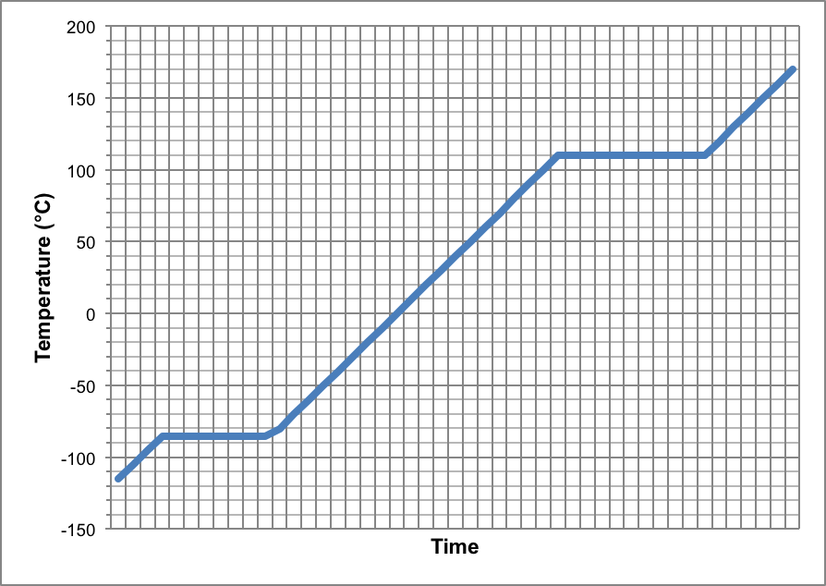
B
A
C
D
E

(a) State the melting and boiling point of methyl disulfanyl methane. (2 marks)

Melting point (°C) | -85
Boiling point (°C) | 110

(b) In terms of the kinetic theory, explain what is occurring at section D. (2 marks)

- substance is boiling (liquid to gas)
- temp is constant as energy is being used to break bonds between the particles
OR
- E_{k} constant while E_{p} is increasing

(c) What would the transition from C to A be called? (1 mark)

- solidification / freezing

(d) Would the transition from C to A be an exothermic or endothermic process? Explain. (2 marks)

- exothermic
- solids have lower E_{k} and E_{p} than liquids, so particles would need to release energy to achieve a solid conformation

A sample of methyl disulfanyl methane underwent analysis to determine its molecular formula. It was already known that the substance contained only the elements C, H and S. A 0.306 g sample of the pure liquid was combusted in oxygen and this produced 0.290 g of carbon dioxide, 0.176 g of water and also some sulfur dioxide gas.

(e) Calculate the empirical formula of methyl disulfanyl methane. (8 marks)

OR

m(C) = 12.01 / 44.01 x 0.290  = 0.0791388 g  m(H) = (2 x 1.008) / 18.016 x 0.176  = 0.01969449 g  m(S) = 0.306 - 0.0791388 - 0.01969449  = 0.2071667 g  n(C) = 0.0791388 / 12.01  = 0.0065894 mol  n(H) = 0.01969449 / 1.008  = 0.01953818 mol  n(S) = 0.2071667 / 32.07  = 0.00645983 mol | n(C) = n(CO₂)  = m/M  = 0.290 / 44.01  = 0.0065894 mol  m(C) = nM  = 0.0065894 x 12.01  = 0.0791388 g  n(H) = 2 x n(H₂O)  = 2 x (0.176 / 18.016)  = 0.01953818 mol  m(H) = 0.01953818 x 1.008  = 0.01969449 g  m(S) = 0.306 - 0.0791388 - 0.01969449  = 0.2071667 g  n(S) = 0.2071667 / 32.07  = 0.00645983 mol

 | C | H | S
ratio | 1 | 3 | 1

Therefore EF is CH₃S

If the molecular weight of methyl disulfanyl methane is 94.2 g mol⁻¹;

(f) Calculate the molecular formula of the substance. (2 marks)

M(EF) = 47.104 g mol⁻¹

M / M(EF) = 94.2 / 47.104
= 2

Therefore MF is C₂H₆S₂

(g) Write a balanced equation for the combustion of methyl disulfanyl methane in oxygen. (1 mark)

2 C₂H₆S₂ + 11 O₂ → 4 CO₂ + 6 H₂O + 4 SO₂

Question 37 (17 marks)

Hydrogen sulfide (H₂S) is a common contaminant in drinking water and causes the water to have an unpleasant taste and odour. The addition of chlorine gas is one method by which the hydrogen sulfide can be removed and the water purified.

A tank containing contaminated water was to be treated in this way to remove the hydrogen sulfide. The equation below illustrates the reaction that occurs when chlorine is added.

4 Cl₂ (g) + H₂S (aq) + 4 H₂O (l) → H₂SO₄ (aq) + 8 HCl (aq)

(a) Draw the structural formula of chlorine and hydrogen sulfide, representing all valence shell electron pairs either as : or – . (2 marks)

Cl₂ | H₂S
••  ••  ••  ••  ••  ••  Cl – Cl | H – S  l  H  ••  ••

The process represented by the equation above is also a redox reaction.

(b) State which substance has been oxidised and which has been reduced. Use oxidation numbers to support your answer. (4 marks)

- Cl₂ reduced
- (0) to (-1)
- H₂S oxidised
- S from (-2) to (+6)

The tank held 20 000 L of contaminated water. The concentration of hydrogen sulfide in the water was 7.13 x 10⁻⁴ g L⁻¹.

(c) Calculate the volume of chlorine at STP that would be required to remove all the hydrogen sulfide from the water. (4 marks)

m(H₂S) = cV
= 0.000713 x 20000
= 14.26 g

n(H₂S) = m/M
= 14.26 / 34.086
= 0.4183536

n(Cl₂) = 4 x n(H₂S)
= 0.4183536 x 4
= 1.673414

V(Cl₂) = 22.71n
= 22.71 x 1.673414
= 38.00324 L
= 38.0 L

(d) Calculate the final concentration of HCl (in mol L⁻¹) that would be present in the tank after the chlorination process was complete. (2 marks)

n(HCl) = 8 x n(H₂S)
= 0.4183536 x 8
= 3.346829

c(HCl) = n/V
= 3.346829 / 20000
= 0.00016734 mol L⁻¹
= 0.000167 mol L⁻¹ OR 1.67 x 10⁻⁴ mol L⁻¹

Both of the products in this reaction (hydrochloric and sulfuric acid) are strong acids.

(e) Explain the difference between a strong and weak acid. (2 marks)

- strong acid completely ionises in solution
- weak acid only partially ionises

(f) Sulfuric acid is ‘diprotic’. Explain what this term means, using equations to support your answer. (3 marks)

- diprotic means 2 acidic / ionisable hydrogens
- H₂SO₄ → H⁺ + HSO₄⁻ OR H₂SO₄ + H₂O → H₃O⁺ + HSO₄⁻
- HSO₄⁻ H⁺ + SO₄²⁻ OR HSO₄⁻ + H₂O H₃O⁺ + SO₄²⁻

Question 38 (20 marks)

But-2-ene (also known as 2-butene and butylene) has the molecular formula C₄H₈. It is a colourless gas at room temperature and is found in small quantities in crude oil. More often it is formed by the catalytic cracking of longer hydrocarbons. But-2-ene and its isomers are often used in a polymerisation reaction to make substances such as synthetic rubber.

The diagrams below show both geometric (cis/trans) isomers of but-2-ene.

C = C
H CH₃
H₃C H
C = C
H₃C CH₃
H H

trans cis

(a) Label the diagrams above as being in either cis or trans conformation. (1 mark)

The boiling points of the isomers only differ by a few degrees, with the cis isomer boiling at 4 °C and trans isomer boiling at 1 °C.

(b) Explain, in terms of bonding, why the boiling points of both but-2-ene isomers are low.
(3 marks)

- but-2-ene is a covalent molecular substance
- therefore has weak intermolecular forces
- so only a small amount of heat is required to disrupt the bonding, resulting in a low boiling point

(c) There are four (4) more isomers which have the molecular formula C₄H₈. Draw and name them below. (4 marks)

Structure:  C = C  H CH₂ – CH₃  H H  IUPAC name: but-1-ene | Structure:  C = C  H CH₃  H CH₃  IUPAC name: methylpropene
Structure:  IUPAC name: cyclobutane | Structure:  CH₃  IUPAC name: methylcyclopropane

But-2-ene can be converted into butane by a single reaction.

(d) Name this type of reaction. (1 mark)

- addition / hydrogenation

(e) Write a balanced equation for this reaction. (1 mark)

- C₄H₈ + H₂ → C₄H₁₀
OR
- CH₃CH=CHCH₃ + H₂ → CH₃CH₂CH₂CH₃

Butane also has a boiling point of 1 °C, the same as the trans isomer of but-2-ene.

(f) Describe a chemical test that you could use to distinguish between the two substances. Include expected observations in your answer. (3 marks)

- addition of bromine (l) / (aq) to both
- orange colour of bromine would fade to colourless in but-2-ene
- orange colour would remain in butane

But-2-ene burns in air according to the following equation;

C₄H₈ (g) + 6 O₂ (g) → 4 CO₂ (g) + 4 H₂O (g)

If 11.3 kL of oxygen gas, stored at STP, was mixed and combusted with 4.8 kg of but-2-ene;

(g) Calculate the limiting reagent. (4 marks)

 | C₄H₈ | O₂
n(present) | n = m/M  = (4.8 x 1000) / 56.104  = 85.555397 | n = V/22.71  = (11.3 x 1000) / 22.71  = 497.57816
n(required) | n = 497.57816 / 6  = 82.929693 | n = 85.555397 x 6  = 513.33238

Therefore O₂ is LR

OR

Stoichiometric ratio O₂ / C₄H₈ = 6 / 1 = 6
Actual ratio O₂ / C₄H₈ = 497.57816 / 85.555397 = 5.8159

Therefore O₂ is LR

(h) Calculate the mass of excess reagent. (3 marks)

n(xs C₄H₈) = 85.555397 - 82.929693
= 2.625704

m(xs C₄H₈) = nM
= 2.625704 x 56.104
= 147.3125 g
= 147 g

Question 39 (15 marks)

Baking powder is used as a raising agent and is often listed as an ingredient in cake recipes. ‘Single acting’ baking powder consists of one leavening agent, such as sodium bicarbonate (sodium hydrogen carbonate, NaHCO₃). This is mixed with an acidic substance such as calcium dihydrogenphosphate monohydrate (Ca(H₂PO₄)₂H₂O), as well as other ingredients such as corn starch or sodium aluminium sulfate.

The equation below shows a simplified version of the leavening process, involving the reaction between sodium bicarbonate and calcium dihydrogenphosphate monohydrate. This reaction releases carbon dioxide gas, which in turn causes the cake to rise.

14 NaHCO₃ + 5 Ca(H₂PO₄)₂H₂O → Ca₅(PO₄)₃OH + 7 Na₂HPO₄ + 18 H₂O + 14 CO₂

4.83 g of baking powder was added to a cake mixture and the 2 active ingredients, NaHCO₃ and Ca(H₂PO₄)₂H₂O, were both entirely consumed. This resulted in the production of 392 mL of carbon dioxide gas at STP.

(a) Calculate the percentage by mass of both sodium hydrogen carbonate (NaHCO₃) and calcium dihydrogenphosphate monohydrate (Ca(H₂PO₄)₂H₂O) in the baking powder. (7 marks)

n(CO₂) = V / 22.71
= 0.392 / 22.71
= 0.017261118

n(NaHCO₃) = 0.017261118

m(NaHCO₃) = nM
= 0.017261118 x 84.008
= 1.450072 g

% NaHCO₃ = 1.450072 / 4.83 x 100
= 30.02219%
= 30.0%

n(Ca(H₂PO₄)₂H₂O) = 0.017261118 / 14 x 5
= 0.006164685

m(Ca(H₂PO₄)₂H₂O) = nM
= 0.006164685 x 252.068
= 1.5539198 g

% Ca(H₂PO₄)₂H₂O = 1.5539198 /4.83 x 100
= 32.17225%
= 32.2%

In comparison to baking powder, baking soda consists only of sodium hydrogen carbonate (NaHCO₃). This is used in recipes when an acid is already present in one of the other ingredients, such as yoghurt, vinegar or buttermilk.

Sodium hydrogen carbonate is a white, crystalline, brittle solid. It is also a weak base that is completely soluble in water

(b) Explain, in terms of structure and bonding, why sodium hydrogen carbonate is a brittle solid. (3 marks)

- ionic bonding present
- rigid 3D lattice consisting of cations and anions
- if force applied, like charged ions will align and repel, causing brittleness

(c) Circle two words below that correctly classify an aqueous solution of sodium hydrogen carbonate. (2 marks)

Strong electrolyte OR Weak electrolyte OR Non electrolyte

Good conductor OR Poor conductor OR Non conductor

Baking soda is often mixed with vinegar to create the ‘erupting volcano’ effect in Year 8 science experiments. 100 mL of vinegar was poured into a beaker and a few drops of universal indicator were added. A spoonful of baking soda was then dropped into the beaker.

(d) Assuming the baking soda was in excess, describe the predicted observations for this reaction. (3 marks)

- white powder was added to red / pink / orange solution
- powder dissolves, colourless odourless gas produced
- final solution is dark green / blue / purple in colour

End of questions

